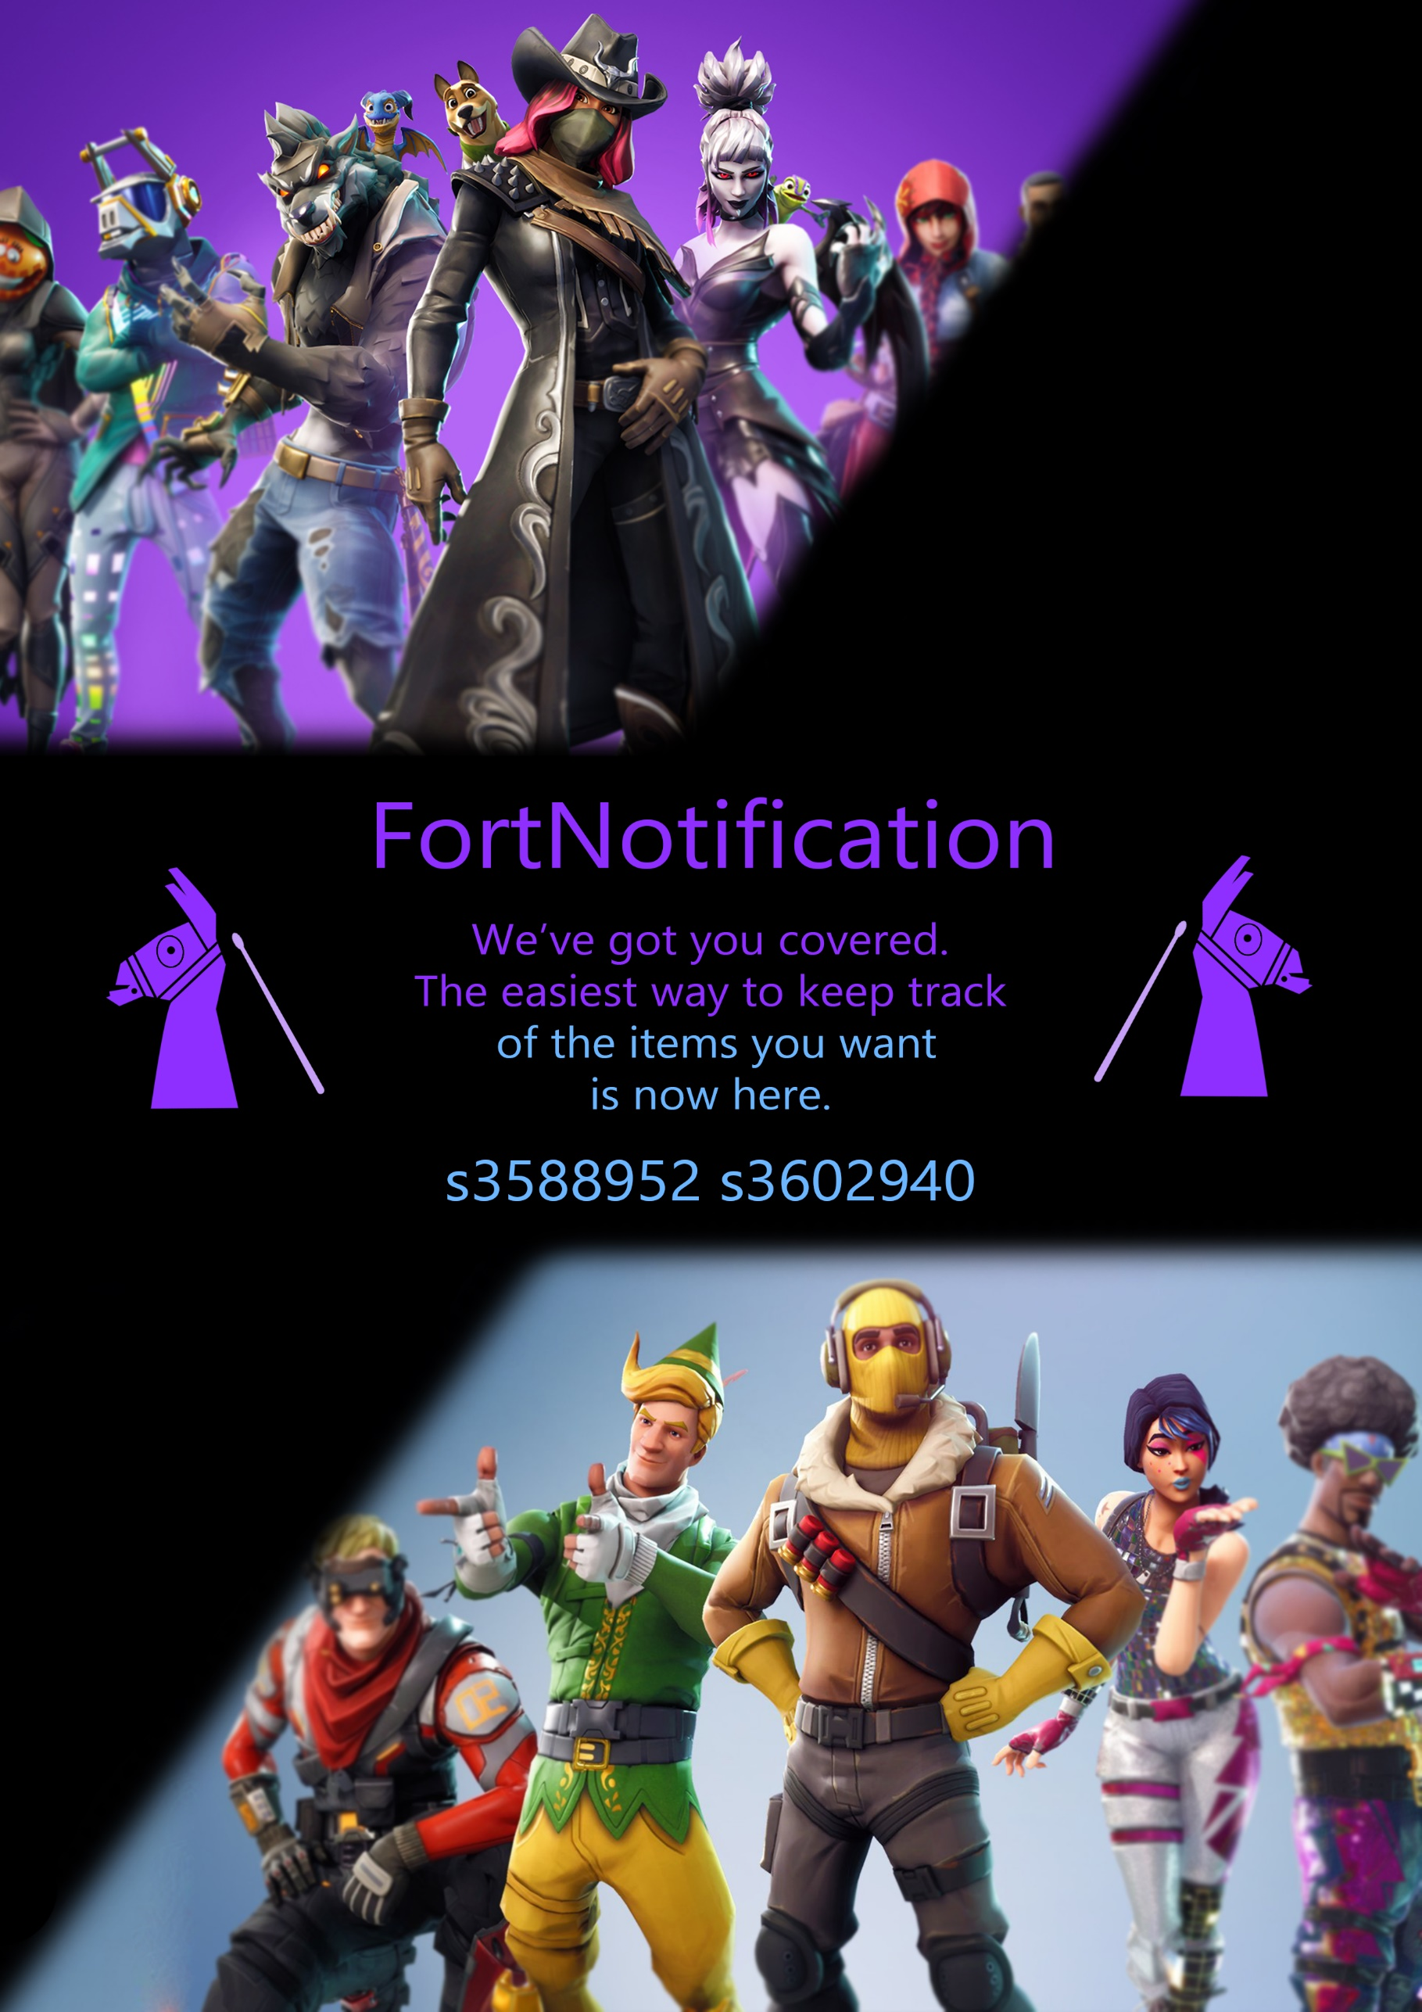



FortNotification

**Team Members:**

s3588952 – Isaac Underhill  
s3602940 – Alex Rosenzweig

**Contributions:**

50/50

**Links:**

Github: <https://github.com/isybub/fortnotification>

FortNotification: <http://www.fortnotification.appspot.com>

**Project**

Option 1: Development of a cloud application using your own idea and strengths

## Summary

The purpose of our project is to use the Fortnite API, and quite a few of Google’s APIs to create a meaningful website that fills a current gap in the market. There is no current easy alternative to FortNotification, meaning it has the potential for marketing, advertising and real-world usage.

## Introduction

Fortnite is a currently popular video game, that can be played on many different machines and computers. It has a player base of approximately 125 million people.

This game has an internal “Store”, where players can spend virtual currency to purchase “Skins” and “Items”. These skins and items are rotated through the store on a 24-hour basis, and no two days will have the same items. There are currently nearly 400 items in the game that will be sold on the store, and as such it can take quite some time for certain items to arrive on the daily rotation.

This leads to an issue. Players want a specific item. Players will have to log into the game every single day for an undetermined amount of time to purchase that specific item.

Here’s where FortNotification comes in. A user will log in with Google Authentication, list the few items they wish to purchase, and each day as the store rotates, if it contains one of the items that the user wants, they will receive an email ASAP describing the items in the store.

This means users can rest easy knowing they will be able to purchase the item they want, and not have to log into the game every single day to check.



## Architecture

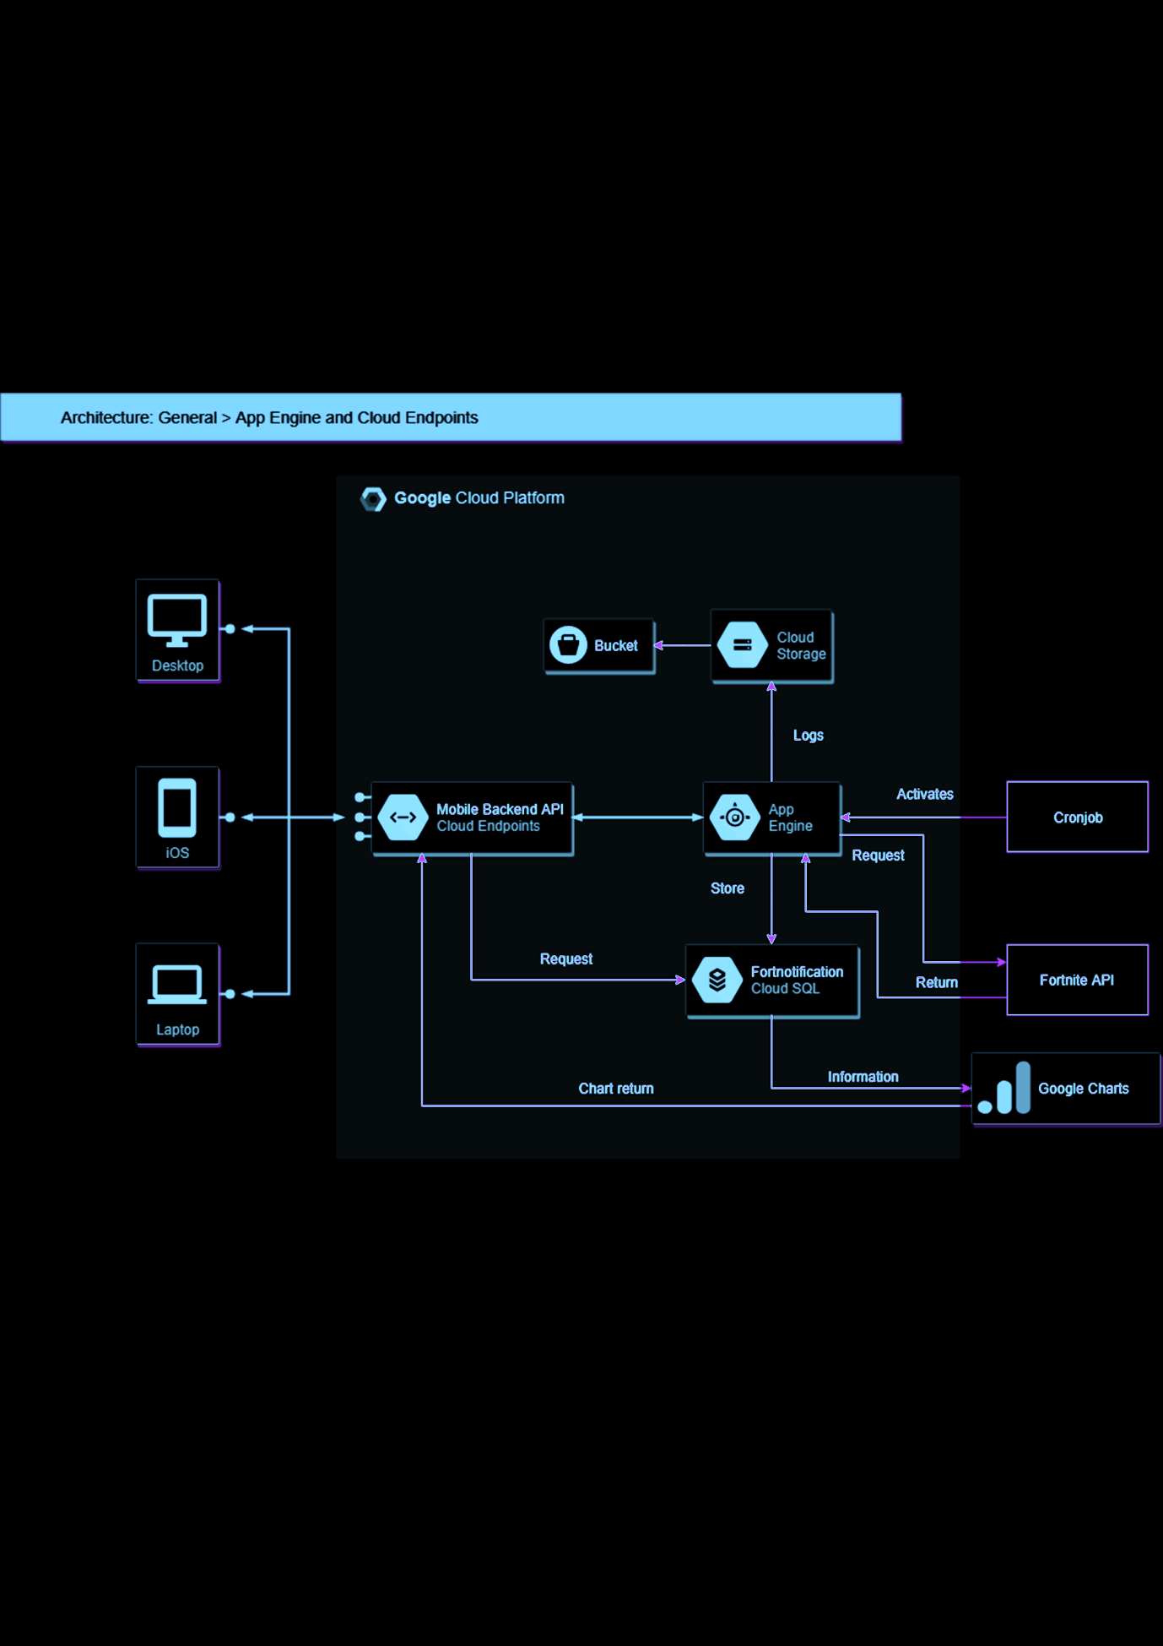

The website is hosted on Google Apps Engine, using the SQL API, Google Storage API, Charts API, User Service API, and the Fortnite API. Most of these services are backend, and the user will not notice, aside from google charts.

The user will access the website, which runs a call to the Google Charts API, to display the top 5 most popular “requested” items. The user may then login to the website, using the Google User Service API. Having logged in, the user may continue to their requested items.  
On the item selection page, the user is greeted by a text area where they can specify the items they wish to “request” from the store. Entering this data begins the backend process as follows:  
Process the input and itemize each point as separate elements in an array, store the information using google SQL API, and save the user’s information using Google Storage API.   
Each morning at 10:05AM a cronjob will be run to get the information from the Fortnite API about the items in the store on that day. These items will be compared against users and then emails are sent out to the users that have matching items in the store they “requested”.

# API Use

For the majority of our API use, we are looking towards the future. Fortnite has upwards of 100 million players; if our website to capture even 0.1% of this player base, it would be 100,000 users. A such, these extreme figures must be taken into consideration. Processing data locally with 100,000 separate entries, and possible thousands of accesses a day, would not scale well.

**Storage API:**

We use the google storage API to log the user’s movements on the website. Files are sorted by year, month, day, and then logged. The information is login time, with a unique google user ID, and the user’s email. Once a user has submitted items to be requested, another logging event occurs, this time documenting the items requested, the User ID, and email.

**This usage is important to track statistics about website usage, and to confirm the availability of certain items. For example, we will run an algorithm that can create a histogram of website usage to confirm the popularity and direction of usage. Using this we can determine whether we will need to prepare for more scaling or start slowing down production, saving money.**

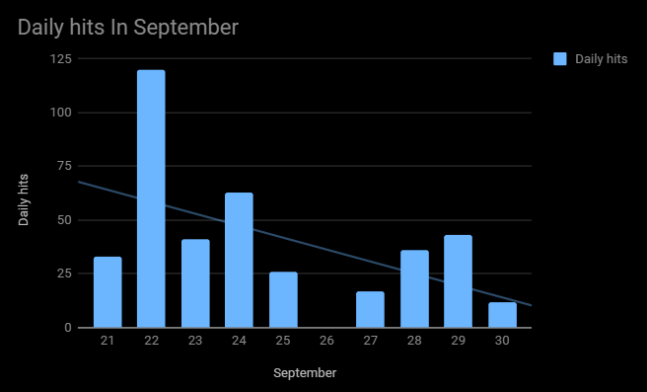

**You can see the trendline going down as we slow down production of the website, less website resetting and less hits, however once in full production, these numbers will likely have a** positive trend line.

**Charts API:**

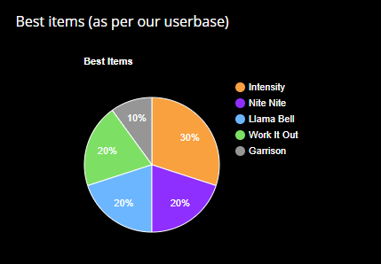**Google Charts API is one of the most powerful online chart creators, simple to execute and extremely fast. We have done several tests during the production and development of the website, we found there is** no noticeable time **between page load, and chart load. This is partially due to the hosting on App Engine, and the** high availability **of all google servers, in all locations. Here we have an example chart from the website, which shows the current most popularly requested items. This is useful for new users to see what other players enjoy and are looking for; New sign-ups will appreciate the reminder of a few popular items they may have forgotten about**



**Fortnite API:**

The core service in this assignment, the Fortnite API. We use this API to access the daily Fortnite store, to compare with our user’s requests, before sending out emails. We have completed several tests against the various functions of this API to ensure the performance of it. The graph here displays 4 different tests:   
1. The only function we require, daily store items  
2. The most intensive function on the API, listing all current Store items  
3. Requesting specific user statistics  
4. Requesting “Leaderboard”

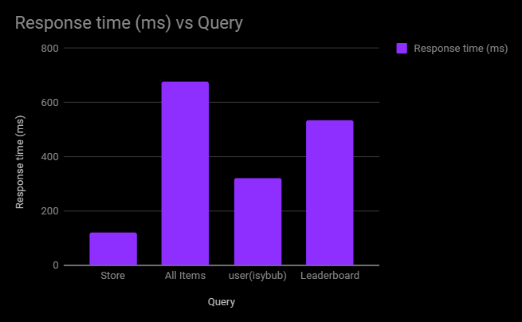

**User Service API:**

Login. It’s one of the most important aspects to any website that has any form of service. Google’s user service API makes this one of the easiest functions to implement. It is simply a few lines of Google’s code, and there you have it. User information, easily accessible, and a login button that is easy and simple to use.

**SQL API**

As mentioned before, there is the possibility of an extreme count of users, it is a clear option then, to use either Hadoop MapReduce, Google BigData, or the google SQL API. We decided due to familiarity to continue with the SQL API, as this would be quick to develop for. In terms of scaling for the future, the difference between Google’s SQL API, and Google’s BigData is very little, and as such a transfer of data and usage would be easily computed. We duplicated our data in the SQL database and ran a few of our commands on it, here are the results with 200,000 data entries. The backup query takes some time to run, this is fine as it is not a forward-facing query, as such, it does not affect performance for users.

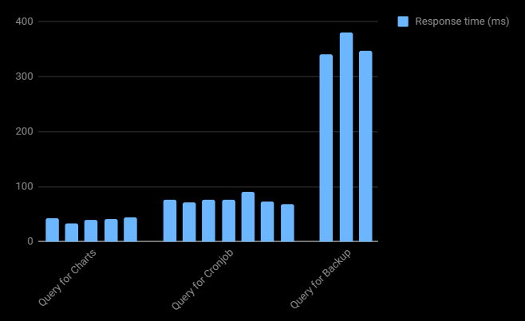

# 

# What’s so cool about all this?

From the user’s point of view, the process is extremely laidback and low on interaction. All they need to do is login with google, which can be one click if they are already using a browser they are logged in with. After this, they type the list of items they wish to be notified of, and that’s it. An extremely simple two step process will give us all the information we need to complete our side of the transaction.  
**Speaking of our side of the transaction, how does that work?**

By manipulating the input string, and storing it into the database, we have



|  |  |
| --- | --- |
| Users | |
| Email | UID |
| Isybub6@gmail.com | 106148742696891494647 |
| example@gmail.com | 113916595269314910627 |
| eggy@gmail.com | 102394564853386161998 |
| fortnite@gmail.com | 108255305514332138299 |

## How does that work?

# SQL Example tables

|  |  |
| --- | --- |
| Items | |
| UID | Item |
| 106148742696891494647 | Llama Bell |
| 106148742696891494647 | Fresh |
| 113916595269314910627 | Pumpernickel |
| 113916595269314910627 | Llama Bell |

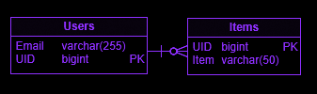

Due to the light database design, we have decided it is unnecessary to use BigData or MapReduce for such a simple layout. The performance of the SQL engine will be monitored, however; If we see any significant changes in response speed, we will easily and quickly move the database over to BigData.  
Google’s User Service API contains a fantastic feature, the Unique Google ID. That is, every user that has a google account, has a unique, permanent ID tied to their account. This is what we use for the primary keys in both tables, and is a unique way of identifying users whilst avoiding sequential user IDs.

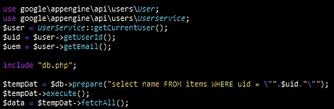

This snippet of code will get the current user, put their email and user id into variables, and then run an SQL query on it, using the User Id as a key to find the information that we are looking for; The items that a user has requested in the database.   
The first 5 lines are littered throughout the codebase, and the google User ID from the API is used extensively within the website, for different functions requiring a uniquely identified user. This function has dramatically reduced the necessary code for identifying users.



# Related work

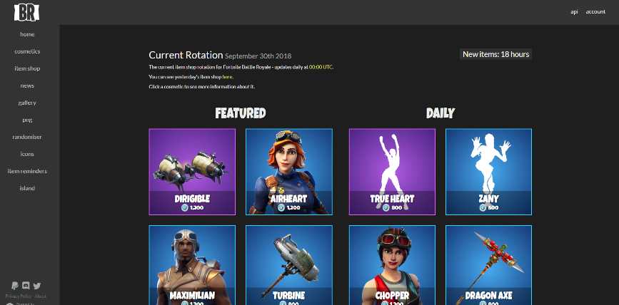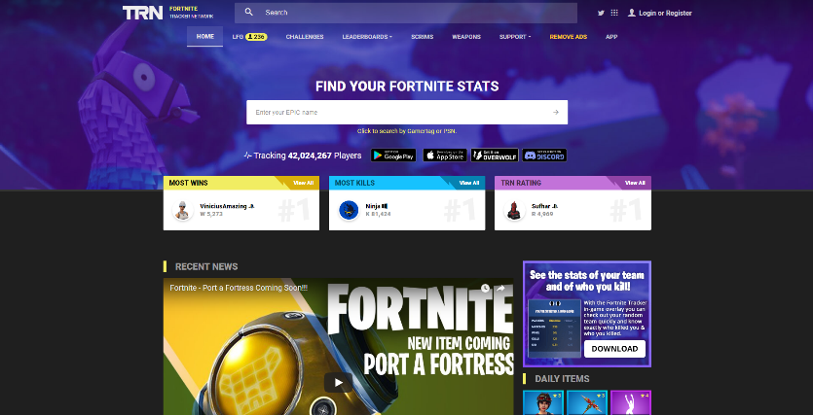

<https://fnbr.co/shop/>

A hub to view the store  
items online rather than logging into the game.   
This still takes time, and a good memory to check each day. Lacking a notification feature.

[https://fortnitetracker.com/](https://fortnitetracker.com)

Using a very similar Fortnite API, players can get their stats of the last season and compare with other players. Similarly lacking a notification feature.

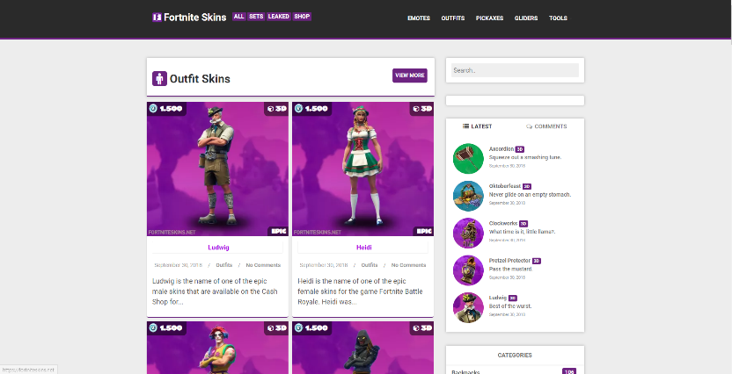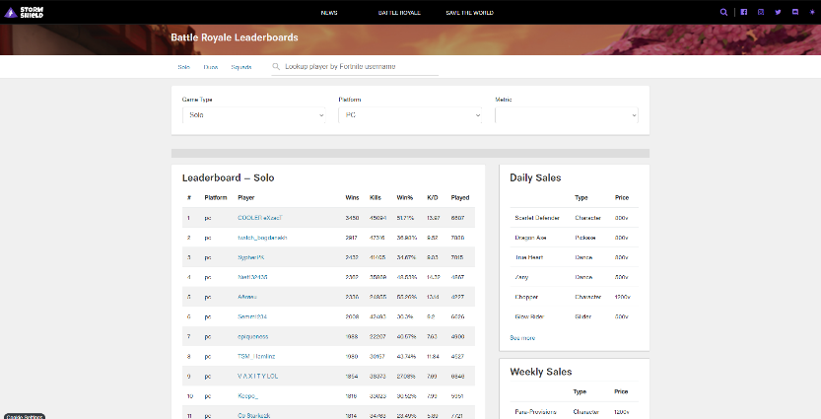

<https://www.stormshield.one/pvp>

Fortnite Tracker clone – slightly less favourable website design, however simpler to look at with less on the screen at once.

<https://fortniteskins.net>

Also using Fortnite API, listing all of the items that have ever been available in the store ,and the ones in the store right now.



## Step 1.

Clone the repository

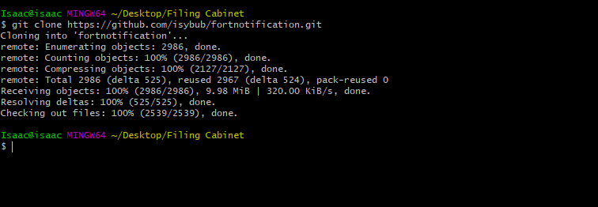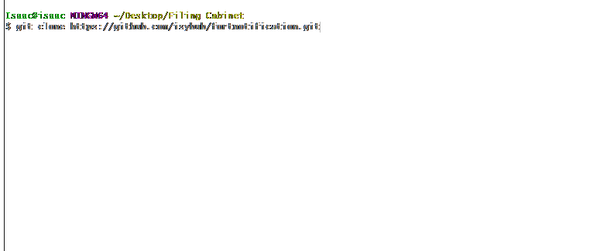

# Step 2.

Create an account on <https://fortniteapi.com>

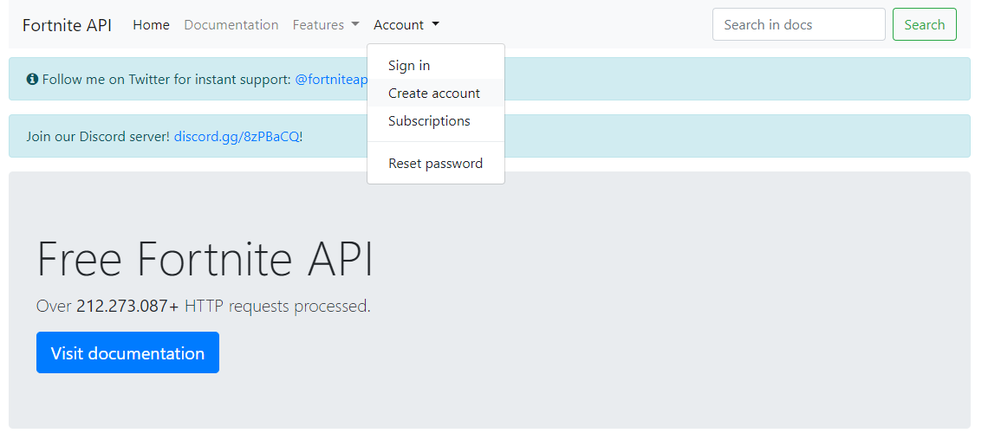

## Step 3.

Once logged in, “Get your FREE key”

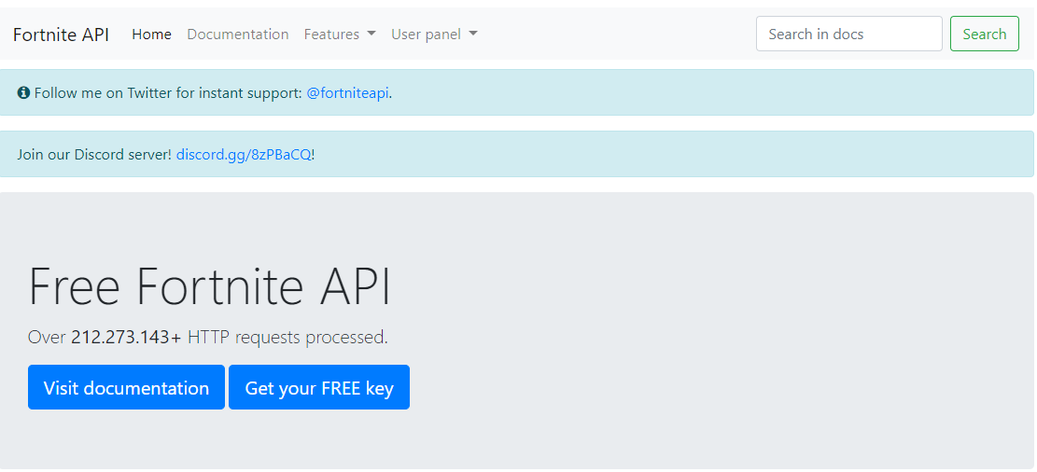

# 

# Step 4.

Copy your new key to clipboard

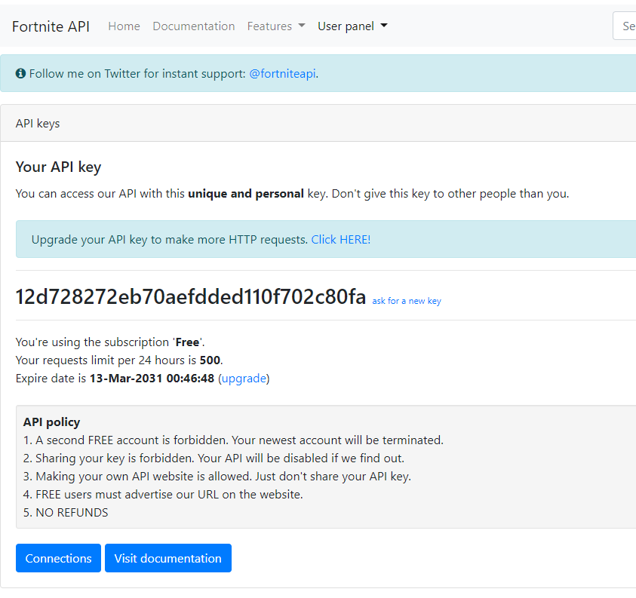

## Step 5.

Paste into the setKey function in your local files

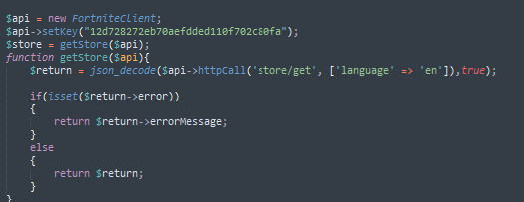

# Step 6. Last step.

Follow the Cloud App Deployment PDF tutorial from RMIT’S Cloud Computing class, tutorial #3

<https://rmit.instructure.com/courses/17760/files/4498035/download?wrap=1>



## User Manual

Alright! Once all of this has been completed, you, and your users are ready to sign up. Simply open your web browser and navigate to <https://www.fortnotification.appspot.com>

1. Click on the “Sign in or register” Button.
2. Click “Go to my subscribed items!”.
3. Enter a list of items you wish to be notified of, for example: “Fresh, Work It Out”.
4. Click submit.

And you’re all done!

FortNotification will now send you an email when the item store has the items you asked to be notified of. It’s that simple.

If you wish to change the items at any point, follow these exact same instructions, and the items you have already requested will be shown, and you can add, remove or keep the same items.

## ­­

## References

1. <https://cloud.google.com/sql/docs/>
2. <https://cloud.google.com/appengine/docs/php/>
3. <https://cloud.google.com/appengine/docs/standard/php/googlestorage/>
4. <https://cloud.google.com/appengine/docs/flexible/php/using-cloud-storage>
5. <https://cloud.google.com/php/getting-started/using-cloud-sql-with-mysql>
6. <https://cloud.google.com/sql/docs/mysql/quickstart>
7. <https://cloud.google.com/appengine/docs/standard/php/mail/>
8. <https://cloud.google.com/appengine/docs/standard/python/config/cronref>
9. <https://cloud.google.com/storage/docs/>
10. <https://cloud.google.com/appengine/docs/standard/php/googlestorage/advanced>
11. <https://cloud.google.com/php/getting-started/using-cloud-storage>
12. <https://cloud.google.com/pubsub/docs/?hl=en_GB>
13. <https://cloud.google.com/storage/docs/access-public-data>
14. <https://cloud.google.com/storage/docs/access-control/lists>
15. <https://googleapis.github.io/google-cloud-php/#/docs/google-cloud/v0.36.0/storage/bucket>
16. <https://fortniteapi.com>